**Assignment-1:**

Connect and disconnect with login Access

* What happens when you login as a non-existent user or username?

Ans. Unable to connect to a VM since I am a Mac user. But when we try to login as a non-existent user, it generally throws an error that the username/user does not exist. Connecting to a virtual machine will actually create a disk image of the physical server with the created OS where you can work and access the things similar to your parent machine.

**Assignment-2:**

Password changing: Unable to perform any of the tasks related to password change since I’m a mac user.

**Assignment-3:**

Working with Directories

* Enter the command **cd /** and then **ls** and then hit **Enter** key

Ans.

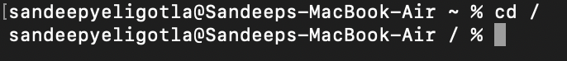

“cd /” will do nothing since the directory is already at the root directory initially and if you are on any other directory, “cd /” will navigate to the root directory. “cd” is used to navigate to the home directory.

“ls” will list out all the directories and the files in that present working directory.



* Enter the command now **cd /home** and then hit **Enter** key and do ls

Ans.

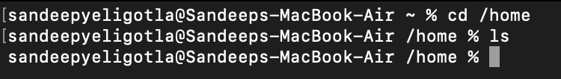

“cd /home” is used to navigate to the home directory and performing ls will list out all the files in home directory. Since there are no files in home directory, it is showing empty in this case.

* Enter “**cd ..”** and hit **Enter** key

Ans.

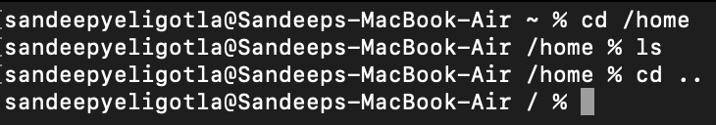

“cd ..” is used to navigate one directory level back. Here, we are navigating from home to user level.

* Now enter **cd /var/www/html** and then type **cd** and hit **Enter** key

Ans.

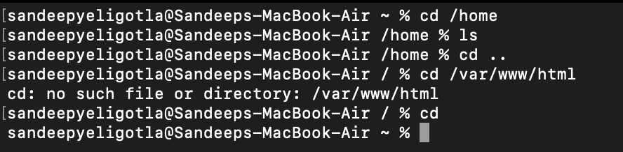

The above command threw an error since there is no such directory or file with the given name. And cd will do nothing since we are already on user level directory which is the outer most level or directory.

* Now type **cd /root** and then hit **Enter** key and do ls

Ans.

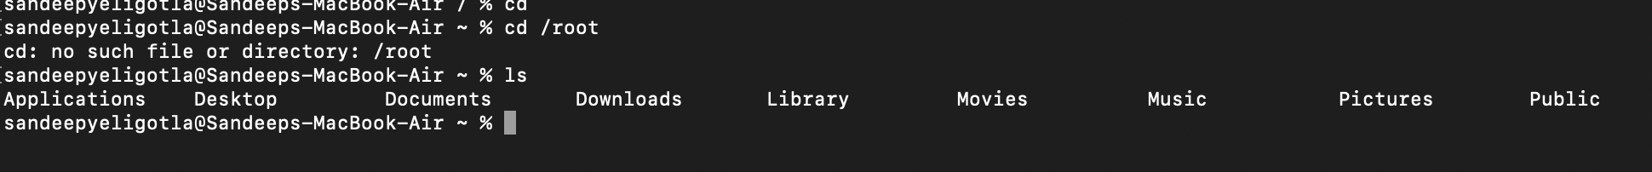

**Assignment-4:**

Working with File Listing

* Go to **cd /etc** and type **ls**
  + Take screenshot and explain what files you have seeing?
  + Take screenshot and explain what different output you found compare to previous command you used?

Ans.

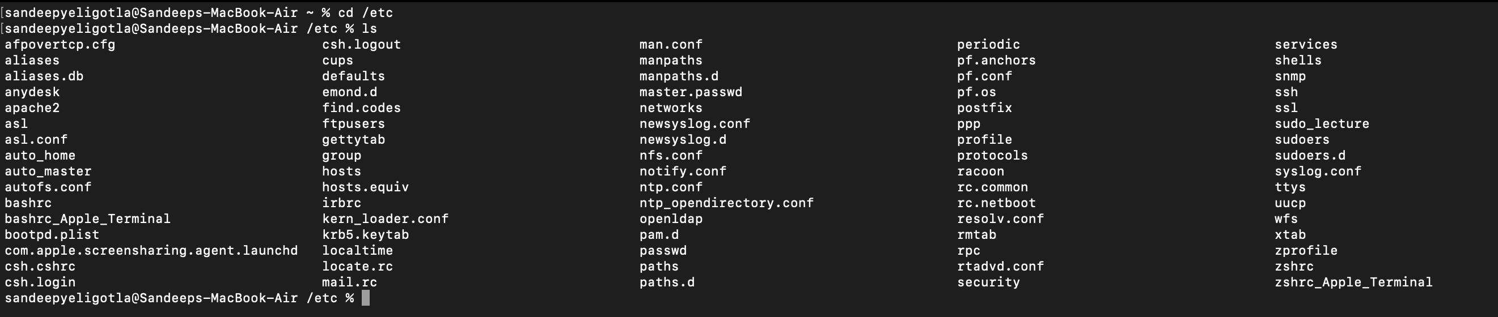

**cd** /**etc** changes directory to the root directory and refers to a folder in the root called **etc. /etc directory contains all the configuration files of which controls the operations of a program.**

* Then type **ls -al** and hit **Enter** key
  + Take screenshot and explain what new file or directory you found?

Ans.

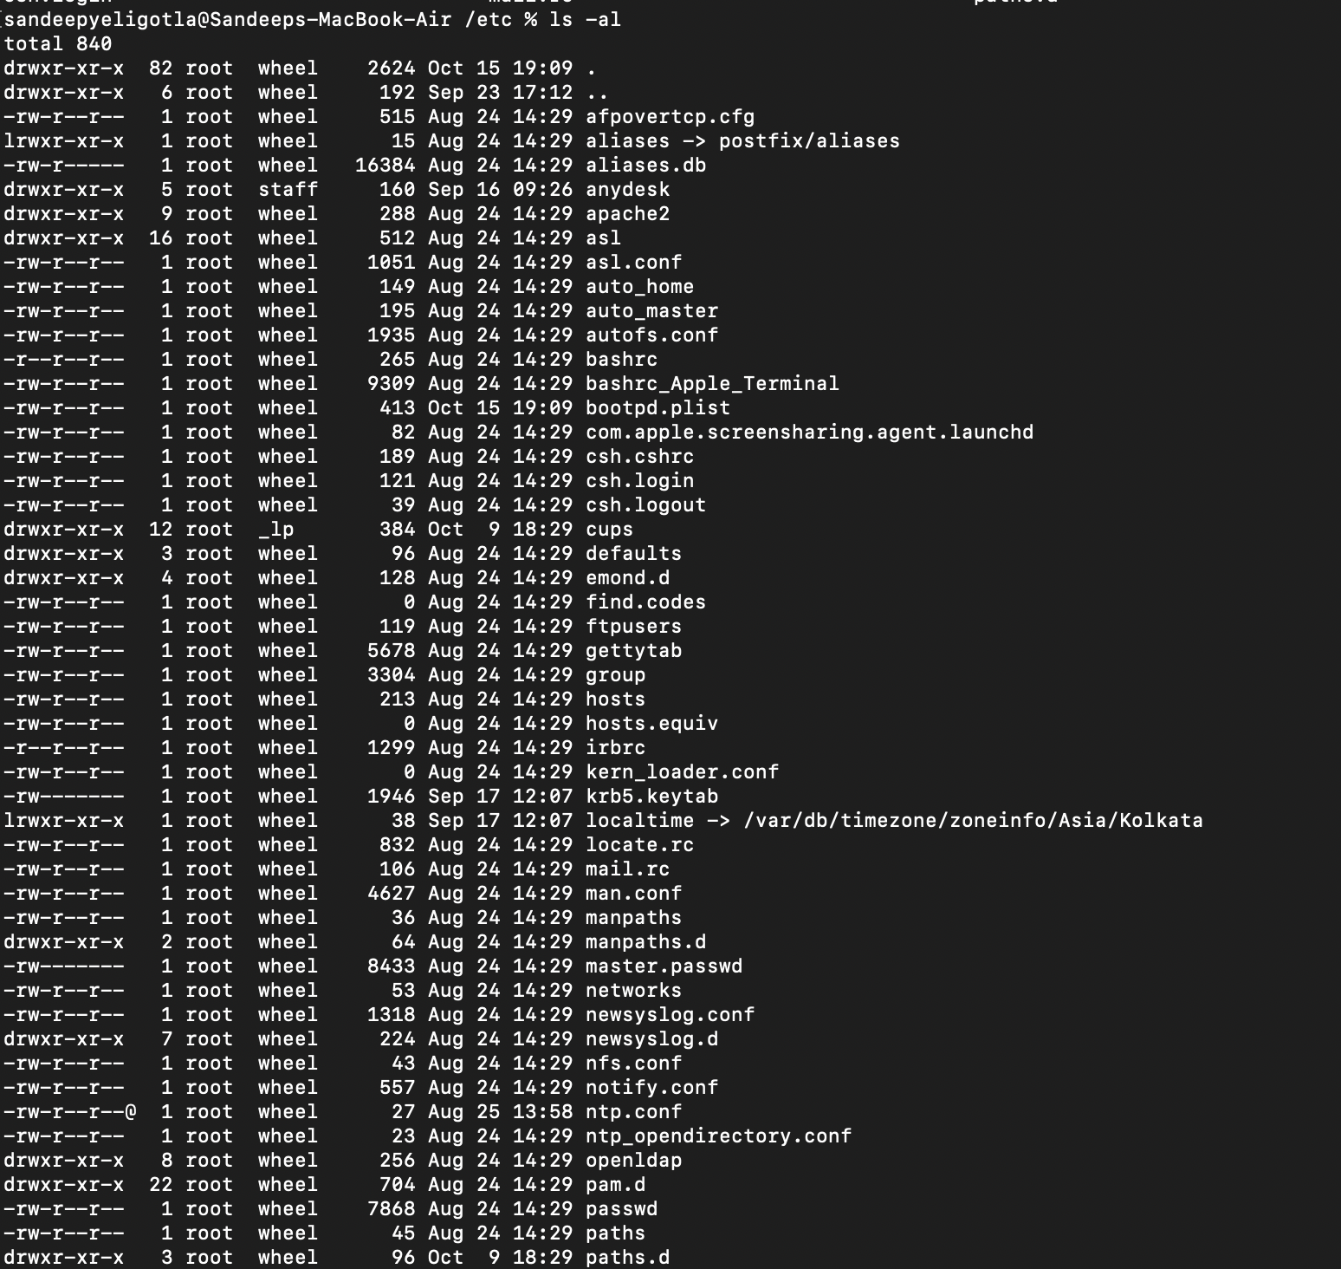

It says that it has a total of 840 root files and displays all of them

* Then use **ls -i** and hit **Enter** key
  + Now see what different output its shows and take screenshot?

Ans.

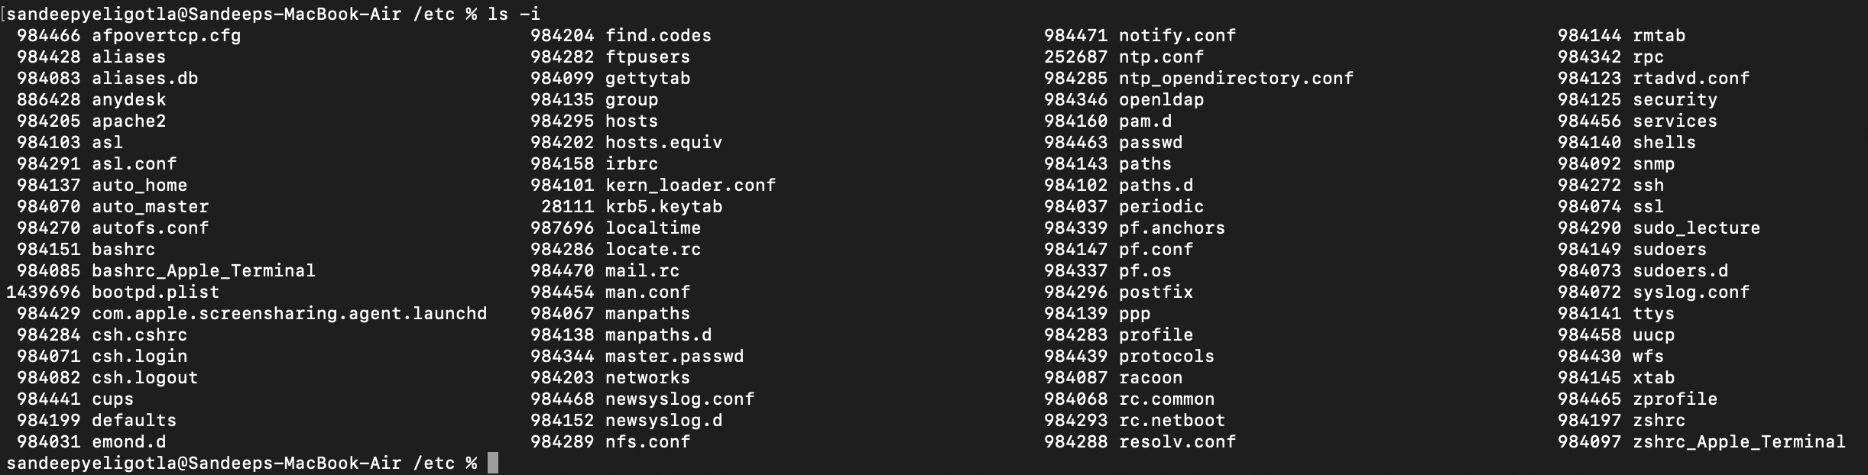

* Then use **ls –help** and see other options about **ls** command
  + Explore it and try with other attribute we can use with **ls** command

Ans.

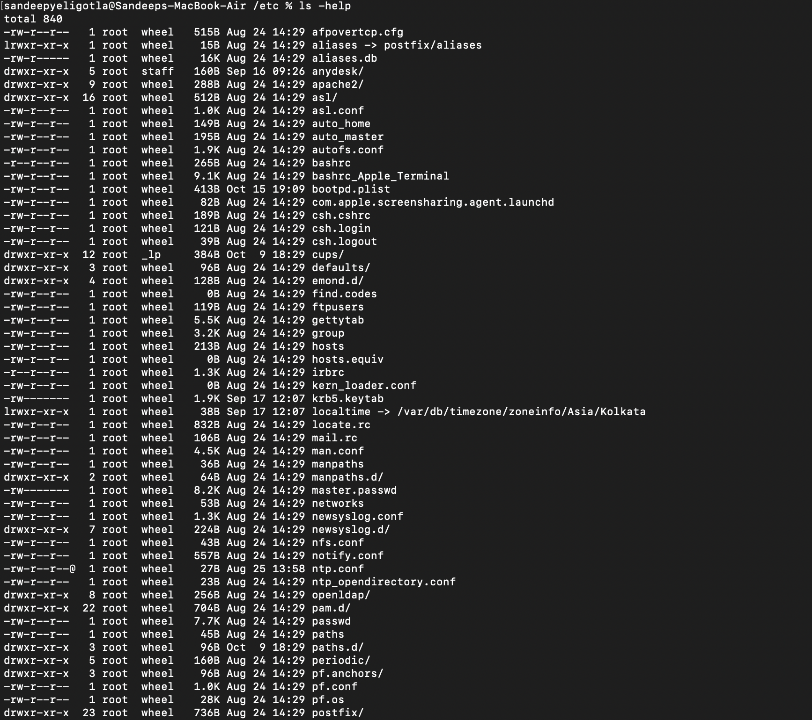

It is listing out all the attributes with which we can perform or list out different files.

**Assignment-5:**

Know where you are and where you working

* Open terminal after restart the linux
  + Check which location you working, type **pwd** and take screenshot

Ans.

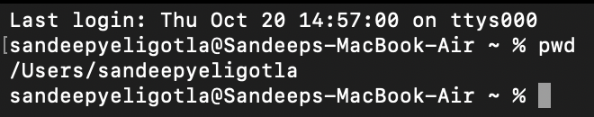

* Now use **cd /var** and hit **Enter** key
  + Do **ls,** and see what output comes, give screenshot?

Ans.

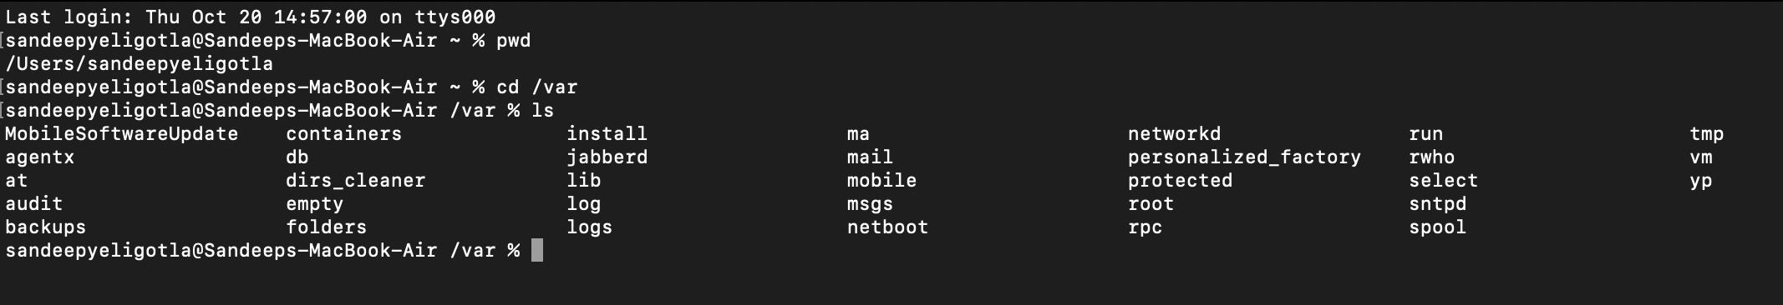

* Do explore other help options of each command to learn more other things we can do with these commands